# Lab: CSS Grids

Problems for exercises and homework for the ["HTML and CSS" course @ SoftUni](https://softuni.bg/courses/web-fundamentals-html5). Submit your solutions in the SoftUni judge system at <https://judge.softuni.bg/Contests/395/Lab-HTML-Structure>.

## Navigation bar

Create a Web Page like the following.

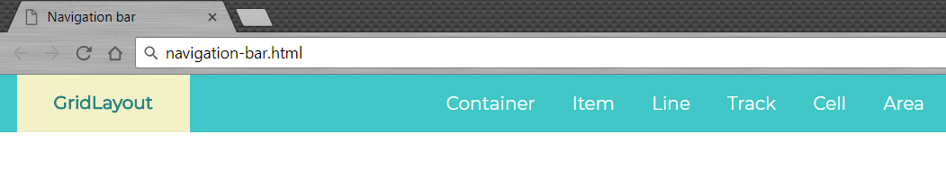

Create two files: **"navigation-bar.html"** and **"navigation-bar.css"**.

### Constraints

* <nav>tag as container
* <body>
  + Margin: 0px;
  + Font family: **‘Montserrat’, sans-serif;**
* <ul> tag for unordered list
  + List style type: none;
  + Float: right;

### Hints

Use:

* #logo with display:inline-block;
* header with display: grid;
* **Grid template columns**

## Simple Grid Layout

Create a Web Page like the following. You are **NOT** allowed to change the HTML.

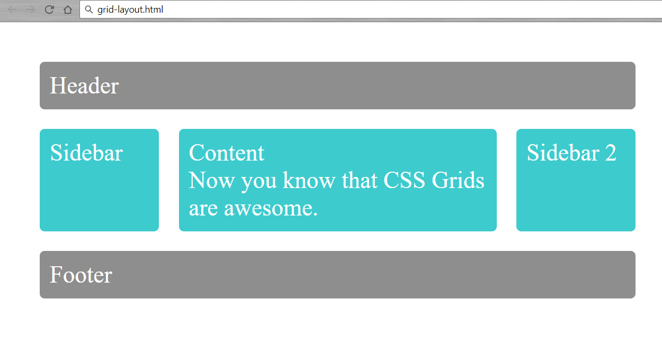

Create one file: "grid-layout.css". You are NOT allowed to change the HTML.

### Hints

Use:

* Grid area names for every div container
* Grid template areas for **.wrapper**

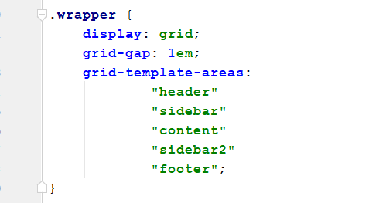

* Move your template areas for different screens

